Jonathan Binns Coursework 1 Person Class Listing and Form Screenshots

Person Class Listing

The using statements and namespace have been omitted.

public class Customer

{

//initializes the variables to be used as private

private int _customerID;

private string _FirstName;

private string _Surname;

private string _EmailAddress;

private string _SkypeID;

private string _Telephone;

private string _PreferredContact;

private int _Matric;

//method to get/set the customers ID

public int ID

{

get

{

return _customerID;

}

set

{

//if-else statement to throw an exception if the ID is going to be set to something outside of the specified range

if (value >= 10001 && value <= 50000)

{

_customerID = value;

}

else

{

throw new ArgumentException("ID is out of range. The range is 10001 - 50000");

}

}

}

//method to get/set the customers first name

public string FirstName

{

get

{

return _FirstName;

}

set

{

//if-else statement to throw an exception if the fist name is going to be set to a blank string

if (value != string.Empty)

{

_FirstName = value;

}

else

{

throw new ArgumentException("First Name cannot be empty");

}

}

}

//method to get/set the customers Surname

public string Surname

{

get

{

return _Surname;

}

set

{

//if-else statement to throw an exception if the surname is going to be set to a blank string

if (value != string.Empty)

{

_Surname = value;

}

else

{

throw new ArgumentException("Surname cannot be empty");

}

}

}

//method to get/set the customers email address

public string EmailAddress

{

get

{

return _EmailAddress;

}

set

{

//if-else statement to throw an exception if the string the email address will be set to a string that doesnt contain an @

if (value.Contains("@"))

{

_EmailAddress = value;

}

else

{

throw new ArgumentException("Please enter a valid email");

}

}

}

//method to get/set the customers skype ID

public string SkypeID

{

get

{

return _SkypeID;

}

set

{

_SkypeID = value;

}

}

//method to get/set the customers telephone number

public string Telephone

{

get

{

return _Telephone;

}

set

{

//if-else statement to throw an exception if the telephone number is going to be set to a blank string

if (value != string.Empty)

{

_Telephone = value;

}

else

{

throw new ArgumentException("Telephone cannot be empty");

}

}

}

//method to get/set the customers preferred contact

public string PreferredContact

{

get

{

return _PreferredContact;

}

set

{

//if-else statement to throw an exception if the preferred contact is going to be set to something that isnt 'Skype', 'Telephone' or 'Email'.

if (value == "Skype" || value == "Telephone" || value == "Email")

{

_PreferredContact = value;

}

else

{

throw new ArgumentException("Please enter either Email, Telephone or Skype");

}

}

}

//method to get/set the customers Matric

public int Matric

{

get

{

return _Matric;

}

set

{

_Matric = value;

}

}

//method to return a string with the method of preferred contact with that method of contacts data

public string getPreferredContact()

{

//if statements to return a string with the preferred method of contact and that methods data

if (_PreferredContact == "Skype")

{

return "Skype: " + _SkypeID;

}

if (_PreferredContact == "Email")

{

return "Email: " + _EmailAddress;

}

if (_PreferredContact == "Telephone")

{

return "Telephone: " + _Telephone;

}

//otherwise it returns null

else

{

return null;

}

}

//method to return all of the customers attributes

public string Display()

{

return _customerID + " Name: " + _FirstName + " " + _Surname + " Email Address: " + _EmailAddress + " Skype ID: " + _SkypeID + " Telephone: " + _Telephone + " Preferred Contact: " + _PreferredContact + Environment.NewLine;

}

}

Screenshots of Form

Blank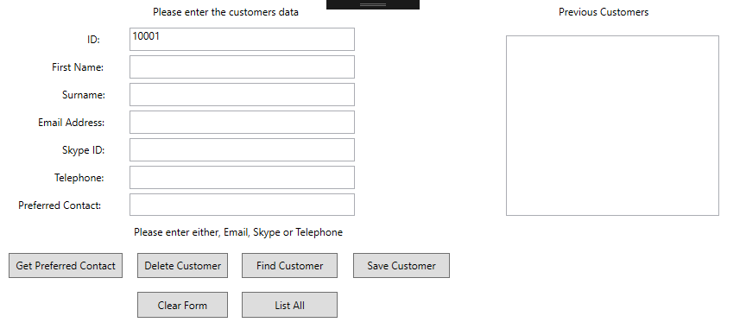

With Data Filled Out

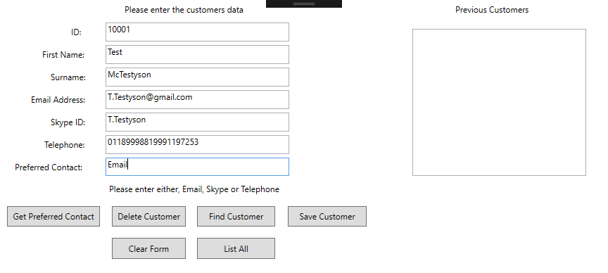

With one Customer Already Added

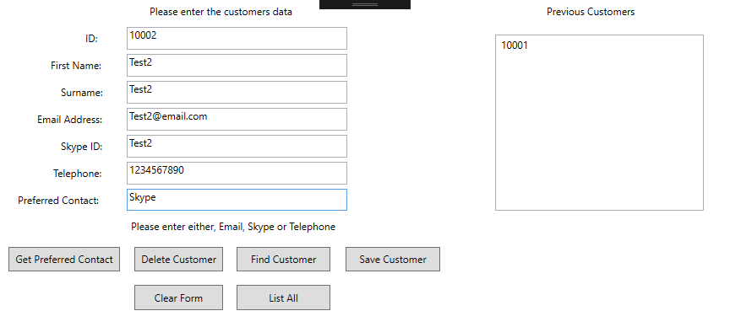

With one Customer in List